

October
Newsletter

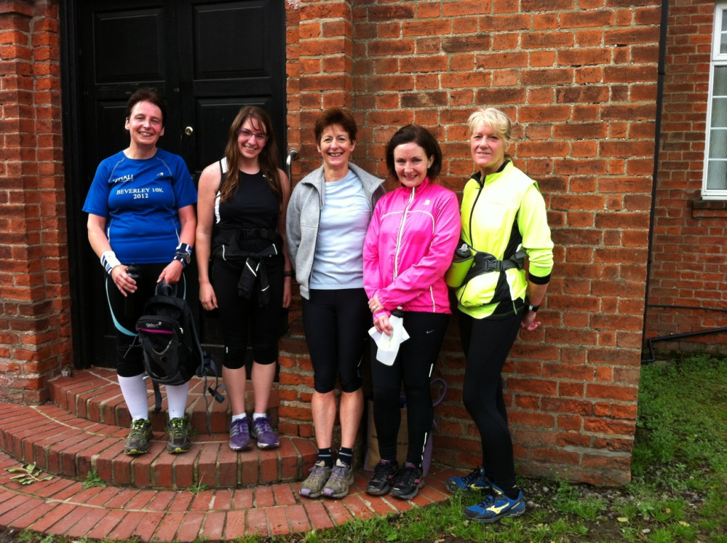

Getting ready for Rudolph ...

WEST HULL LADIES RRC
COMMITTEE MEETING

West Hull Ladies Committee Meeting 08/10/2012

Attendees:- Amanda Dean, Verity Pick, Debbie Watson, Sandra Holdsworth and Louise Ede

Feedback from HAN meeting
DW, SH, AH, AD all attended meeting on 24.9.12.

Coaching Courses
It was decided that there would be 4 places booked on the Leader in Running Fitness course at a cost of £280.00 to the Club. AD to liaise with Rebecca Senior to arrange the date.

AD is also attending the Coach in Running Fitness at a cost of £325.00, although £150.00 will be refunded. AD will need to undertake an assessment April 2013.

Complete Beginners Course by WHL
It is expected that WHL will start offering this course from January 2013. The Training Officers are to discuss the training plan.

Treasurer Role
VV to handover to DW at the end of the month

Secretary Role
LE confirmed she would be stepping down as Secretary. It was discussed the possibility of splitting the role, one role to include sorting out the Agenda and minutes, and the other role just to deal with membership. DW to approach ladies and see who are interested in taking over.

Membership
A list from VV is needed to double check against the members registered on England Athletics. The membership fee for England Athletics will increase to £10.00 per member in April 2013.

Other Business
The meeting should be referred to Club Meeting, not Committee meeting, to try and encourage more ladies to attend.
The possibility of a tempo run on a Friday was raised to assist with the ladies who are marathon training.

There has still been no champagne league prizes given out.

FEED BACK from HAN Meeting

24th September

HAN meets quarterly plus extra meetings, e.g. mentoring meetings.
Next meeting 8th Jan, Octagon (Hull)

Meeting with HAN – Rebecca Senior, chair Anthony ...., minutes secretary Michelle ...
Sttended by Debbie, Ann, Sandra and I. The intention to see if there are bursaries available for Coaching Courses for the training officers and to generally find out what they do. Very brief feedback:

· There is a Coaching Assistant course at Sheffield on 13th – 14th October. There are 2 bursaries available. The cost is £140 and £100 could be reclaimed. The club will discuss further possibilities for training officers to attend coaching training.
· The most useful course appears to be CIRF Coach in Running Fitness. Cost £365 pp. £150 bursary. No dates and a lot more expensive.
· There are free Run Leader courses available, Rebecca Senior will contact us.

HAN is trying to set up workshops – 4 x Road Running and 4 x Track and Field. The workshop contents need deciding e.g. nutrition, psychology of sport, training ...

New website created (though Anthony the chair – could not remember it). Allow input from all, not member bound.

N. Lincoln Park Run being created (Michelle who took minutes).

AOB- asked about increase in UKA fees. Said nothing has been decided but there is a meeting on 8th October. Should hear after that.

There was a fair bit of talk about track stuff. Interesting to hear how the number of ‘track kids’ is growing. Cleethorpes club said they had 70 kids one night!

Our Actions: -

Run Britain email sent to all ladies inviting them to register
Rebecca Senior invited to 8th October committee meeting.
Coaching courses have been researched for training officers to attend

Keep on running: tips for withstanding winter

Dark mornings, icy pavements, gusting winds and sub-zero temperatures ... there are so many reasons to stop running at this time of year. Sam Murphy explains how to take the pain out of winter exercise

(Source: http://www.guardian.co.uk/lifeandstyle/2011/dec/14/running-tips-winter)

Start out warm
I've been running for more than two decades but I still frequently make the classic beginner's error of overdressing. I just hate going out the door cold, but inevitably I end up sweating and stripping off layers, which then flop irritatingly around my waist. Two tricks to help you resist the temptation to wear too much: warm your kit (especially your base layer) on the radiator before you put it on, and do some warm-up exercises in the house before you set off.

Layer up
Layering kit is the tried-and-tested strategy for maintaining and regulating body temperature, but your layers need to be breathable and wicking so they trap heat, not sweat (manmade fabrics like nylon and polypropylene are your best bet, though some natural ones, such as merino wool, work too). But don't overdo it - you'll warm up far more running than you will walking or cycling. With blood being shunted to the working muscles, your extremities are particularly vulnerable to the cold, making gloves and a hat winter essentials. I find winter cycling gloves a good option if it's really chilly (they're designed to keep a non-moving body part warm). If it's only moderately cold, a top with long arms and thumbholes gives some warmth without committing you to coverage for the whole run.

Stay hydrated
With no visible evidence that you are sweating, it's easy to forget about hydration when you're running on colder days. While sweat rates are obviously lower, I recommend carrying fluid with you on runs of an hour or more.

Keep at it
If you don't already have one, set a spring goal to give you a reason to run through the winter.

See ... and be seen
If you are running in darkness, it's reflective clothing and lights that will ensure you get seen by drivers, cyclists and pedestrians, rather than dayglo colours. Look for garments with reflectivity on the arms and legs, rather than the torso, as moving parts are easier to spot. Or buy cheap and cheerful reflective ankle/wrist bands. There's a difference between a light to aid visibility and one to help you see where you are going. A blinking light gives better 'perception distance' (the point at which a driver spots you) than a solid one, but isn't much use if you're trying to light your way. That's where a head torch comes in, leaving your hands free and lighting the route ahead.

What if it's just dull, not dark? According to a Transport for London report in 2009, 34% of pedestrian fatalities in Greater London happened between 3pm and 7pm, with the period October to December - when daylight is scarce - accounting for the greatest number of casualties. Fluoro colours come into their own in low light conditions, but before you reach for the obligatory neon yellow jacket, a study found that the reflectant factor (the amount of light a colour reflects, rather than absorbs) of fluorescent pink and orange rated higher than that of yellow and green. But any bright colour is better than the head-to-toe black so many runners wear ...

Don't be wet
Short of donning full waterproofs, top and bottom, it's nigh-on impossible to stay completely dry on the run. But you can certainly stay dryer. A rain jacket is the essential purchase, but you'll need to weigh up the relative merits of how waterproof a jacket is and how breathable, as an increase in one tends to be accompanied by a decrease in the other. I usually opt for a lightweight water-resistant jacket which keeps the rain off on all but the longest and wettest of runs.

Have happy feet
There's nothing more misery-inducing than cold, wet feet and squelching socks. If you want your tootsies to stay dry, you have two options (OK, three if you count staying at home). Firstly, shoes with a hydrophobic or fully waterproof upper (but bear in mind that you'll still get wet feet if water seeps in over the tops) teamed with some warm, wicking socks. Alternatively, wear your usual trainers with waterproof socks. SealSkinz has been making its chunky waterproof socks for years (like wetsuits for your feet) but has recently introduced some thinner, lighter models, like the snazzily-named Mid Weight, Mid Length Sock (£30 sealskinz.com). If your shoes do get a soaking, unlace them as widely as possible, remove the insole and stuff with newspaper to dry them out (replacing the sodden newspaper regularly). Don't dry out shoes directly on a heat source, though a warm, airy room is fine.

Stay safe
Bear in mind that surfaces are most likely to be icy in the early morning and evening and, if possible, opt for trail or grass which doesn't take on icerink-like properties with the first frost. In adverse weather, consider running loops closer to home rather than tackling a long 'out and back' run, in case you need to bail out. If it's seriously windy, run into the wind when you are fresher, at the start of a run, and have it at your back on the way home. If you're running in the dark, stick to routes that you know well so you are aware of any hazards (a friend ran straight into some low railings at dusk, flying headlong over the top of them) and don't risk getting lost. Avoid wearing headphones so you can stay alert to your surroundings.

Seize the day
Yesterday, I did my long run under a grey sheet of rain that occasionally blew horizontal. It was slippery underfoot and, all in all, a hard slog. Today, it's crisp, cold and still – perfect conditions for a run. The message? Be flexible about your training – if you've got a set of mile reps scheduled but it's gusting 60mph outside, your split times are going to be meaningless so adapt or postpone the session, or hit the treadmill. And if it's a sunny day, just get out there, whatever the schedule says.

Training for Rudolph

Jill
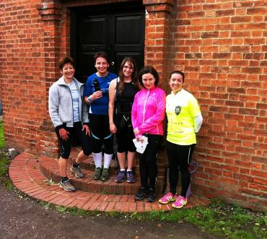
I was a bit fed up when the alarm went off earlier than usual for a Sunday morning so that we could get to Brantingham for 9am, but it was really worth the early start.

I was a bit worried because all of those on the recce are faster runners than me, but I need not have worried as we had plenty of stops to try and learn the course so it was all fine. Although there were some steep hills, the views across the Humber were brilliant, and most of the running was off road which is less stress on your joints.

We greeted a number of friendly dogs and their owners, and also tried to avoid a number of horses in one of the fields. I was pleased to note that up one of the hills there were lots of seats, as I'll probably need them on the real event! Amanda had originally advertised this run as just over 6 miles, but she then suggested that we could just run down this hill to another point which would make it just over 7, so we all did this, but of course when we turned round...it was a steep hill back up!

All in all had a good laugh with everyone, and thoroughly enjoyed the company and the run. Last year, when I first joined the club and I heard that people were doing this event, I thought they were all mad...mmmmm....madness is clearly infectious!

Viking Chase - CLEVELAND SEARCH AND RESCUE TEAM

Amanda

This was my first fell race (not counting Yorkshire 3 Peaks as that is an epic, not a race). I wasn’t sure about doing it because it’s a long drive for an 8 mile race. However, it had been suggested by a friend and it would be nice to see him. As it turned out, although it took 1hr 45min to get there, it was a beautiful drive through Malton and Helmsley to Carlton Bank in the North York Wolds.

I had no idea how long the run would take me as no experience of racing off-road and climbing 1,800ft. It was a lovely day and I was looking forward to the views. We set off up the first of four peaks. It became very steep but I managed to run all of this one. Eventually on top then down and the downs were equally difficult. We were tentatively hammering (is it possible to tentatively hammer?) down a man made path of stones and slabs. You had to be really careful to judge exactly which stone your foot was aiming at and the distance changed with every step and, of course, you were going as fast as you could. If you made a mistake it would be really painful falling on the slabs of rock. This was followed by three more peaks which were very similar except I had to walk at some point on each of them. Enjoying the odd glimpse of fantastic views but very fleeting as you had to watch your feet constantly.

Finished the hills at about 4.5 miles then we were round onto a relatively flat track (as in gentle ups and downs) going through lovely woods just hampered by massive muddy puddles. Unfortunately after at about 6.5 miles there was a fork and the front runner headed right and downhill. All assumed he knew where he was heading and about a dozen of us went wrong. Thankfully, fairly quickly, someone spotted a runner much higher up and we turned back. Although a bit of a pain, I just thought “Hey ho, I’m getting more for my money”. (Checking my GPS later, it added a quarter of a mile and 2mins 30secs to my time).

After that the path dragged on up for a while and I was starting to think it would be nice to see the end. We came over the brow and there below we could see the registration tent. Downhill but the quads were feeling battered so not comfortable. Glad to reach the flat and through the woods before a finally uphill over the field to the finish where I had a mini milky way and some skittles. It took me 87mins 54secs. I wasn’t first over 50 but did not feel bad as the winner was a former national fell running champion. Bet she doesn’t use a bridge for hill training!

It was a lovely day and I enjoyed the scenery as I drove back though feeling fairly tired before reaching Hull.

Fancy it?

http://www.clevelandmrt.org.uk/events.php



Mablethorpe Marathon

Ann

Running a marathon is really hard!!
Wasn't quite sure how this would go - I hadn't put the long miles in that I'd done for Brighton. I'd done more cycling and a couple of triathlons and one 20 miler so hoped that would be enough to get me around ... But at what pace?
Didn't know what to expect of myself - I did think I could do 9:30 min miles but after two miles I knew that wasn't going to work, so dropped to 9:40, which felt a lot more comfortable, so that's where I tried to settle.
This was a two lap race, on very quiet country roads for the most part and sea front for a couple of miles at the end. It took me a long time to settle - only by mile 8 or 9 did I feel ready for a long run. Up until then everything seemed creaky.
So I found my stride and the miles went by. At the half way stage it was very strange to watch the half marathon runners peel off for their finish. It was a lot quieter after that. I chatted to a 60 year old chap who seemed much younger but he couldn't keep up. Before too long I caught with 'Welsh man from Suffolk' who passed me on the first lap. At first I thought the company was a good idea at this difficult part of the run. He was chatty - very chatty indeed. He'd done 29 marathons and wanted to tell me about them all - so what now? Run slower and let him pull away, or speed up and drop him? I didn’t really have a choice, and dropped back as I started to really struggle and he did pull away. At mile 20 the wheels came off and I stopped to walk.
At this point I needed to have a serious talk with myself to get me back on track. I resorted to my 'Alphabet counter' from swimming - each length in the pool is a letter to concentrate on. So A is for Ann - run for Ann, B was 'best effort', C in swimming is catch, but now I decided to 'Catch' my second wind, D - dig deep, E - every step is nearer to the end, F - feel the love (the local and marshal support was great) ... By G I was back on track and didn't get any further with my alphabet because I was back and focused on my running.
The last 6 miles were a real challenge without a doubt so I was very proud of having stayed on track and managed to shave a couple of minutes off my Brighton time with a 4:16 finish time.

Happy days!

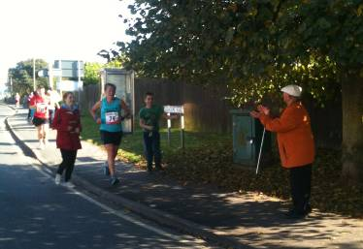

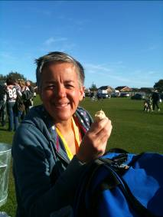

Nottingham Half Marathon

Debbie

I am beginning to love doing big city half marathons with my sister, in fact I regard them as a bit of a mini break, good food, DVDs, and a nice bottle of wine after the event, bliss.
Robin Hood marathon is a huge event, 6500, doing the half marathon. There is a fun run, a relay and right royal jamboree at the start. It was an early start, 9am, and we had a 20 min walk from the car park which kept us warm, by the time we had queued for the loos it was time to get in to our sections. I found it hard to get into my pace and did a lot of weaving for the first 3 or 4 miles. I decided to keep an eye on my GPS and not let my pace drop below 7.5 mph. This worked really well because it kept me focused, in fact the slight injection of pace when necessary actually injected a bit of energy into my legs.
The route is flat with a few inclines but nothing too strenuous. It twists and turns quite a bit which makes it more interesting. I particularly liked running past the university and along the River Trent. The crowd were great, really supportive along the whole route. The last mile was a bit of a drag and a bit crowded, I gave up weaving and waded instead, I heard 1.45 on the loud speaker and had less than a mile to go so I just went for it knowing it was definitely a PB. I crossed the line at 1.46.16 chuffed to bits and not too tired.
My sister knocked 12 minutes off her previous and first half marathon. So we were both very happy. It would recommend it as a half marathon, it was well organised and a great family day out.
Debbie
Racing and Running Events

Date | Event | Distance | Fee | Entry / website
November
4th 11.00 | Deepdale Dash | 10k | £12 | https://www.sportsentrysolutions.com/race_page.php?recordID=159
4th 10.30 | Guy Fawkes 10 | 10 miles | £12 | Online entry
December
1st 8.30 | Rudolph Romp | 24 miles | £9 | Entry form
2nd 9.30 | Percy Pud –Sheffield | 10k | £14 | Entry form
26th 10.30 | Boxing Day 10k | 10k | £10 /£11 on the day | Download entry form from website
January 2013
1st 11.15 | Cleethorpes New Year’s Day 10k | 10k | £9 | Entry form
5th 8.30 | Scarborough Rock | 16/24 miles | £7 | Entry form
27th | Ferriby 10 | 10 miles | Tba | Entry form
February 2013
24th 11.00 | Snake Lane 10 | 10 Miles | £12.50 | Closed!
March 2013
17th 10.00 | East Hull 20 | 20 miles | £18 | Entry form

East Hull Harriers Winter League
East Hull Harriers would like to invite WHL club members who would like to run in any of the East Hull Harriers 2012/2013 winter league. You will not feature in the league itself but can take part in the races
There is no entry fee just turn up on the day
Any further information ring John Baker on (01482) 824648.
Saturday 17th November 2012 – Cross Country
Distance: 3 Miles (staggered start)
If you intend to run in the staggered start races let the organisers know one week before race for handicap purposes
Start Time: 2.10pm Terrain: Mostly grass & fields
Venue: EHH Clubhouse, Saltshouse Road, Hull
Saturday 15th December 2012 – Christmas Handicap
Distance: 6 miles (staggered start)
If you intend to run in the staggered start races let the organisers know one week before race for handicap purposes
Start Time: 2.10pm Terrain: All cross country Venue: EHH Clubhouse,
Sunday 13th January 2013 – Beverley Westwood – EHH Club Championship
Distance (Men): 6.6 miles
Distance (women): 3.3 miles
Start Time: 10am Terrain: Mostly grass
Venue: Newbald Road, Beverley Westwood
Saturday 16th February 2013 – Riverbank Run
Distance: 6 miles (staggered start)
Start Time: 2.10pm Terrain: Riverbank Footpaths
Venue: Ennerdale Leisure Centre, Sutton Road, Hull
Friday 29th March 2013 – Good Friday Hill Run
Distance: 7 miles
Start Time: 10am Terrain: Footpaths & Hills Venue: Elloughton
Thursday 11th April 2013 – Paull Run
Distance: 5.7 miles
Start Time: 7pm Terrain: Riverbank Footpaths Venue: Paull Lighthouse
Check EHH website for all up to date information: www.easthullharriers.com

Keep checking the website for new races and updates: www.westhullladies.org.uk/races.htm Verity, Racing Officer

NOTE: Club Vests must be worn at any races you enter
under the West Hull Ladies running club name.

And finally ...

Chrissie Wellington, 4 time Ironman World Champion reads this before every race ...

IF you can keep your head when all about you
Are losing theirs and blaming it on you,
If you can trust yourself when all men doubt you,
But make allowance for their doubting too;
If you can wait and not be tired by waiting,
Or being lied about, don't deal in lies,
Or being hated, don't give way to hating,
And yet don't look too good, nor talk too wise:
If you can dream - and not make dreams your master;
If you can think - and not make thoughts your aim;
If you can meet with Triumph and Disaster
And treat those two impostors just the same;
If you can bear to hear the truth you've spoken
Twisted by knaves to make a trap for fools,
Or watch the things you gave your life to, broken,
And stoop and build 'em up with worn-out tools:
If you can make one heap of all your winnings
And risk it on one turn of pitch-and-toss,
And lose, and start again at your beginnings
And never breathe a word about your loss;
If you can force your heart and nerve and sinew
To serve your turn long after they are gone,
And so hold on when there is nothing in you
Except the Will which says to them: 'Hold on!'
If you can talk with crowds and keep your virtue,
' Or walk with Kings - nor lose the common touch,
if neither foes nor loving friends can hurt you,
If all men count with you, but none too much;
If you can fill the unforgiving minute
With sixty seconds' worth of distance run,
Yours is the Earth and everything that's in it,
And - which is more - you'll be a Man, my son!

Clubwear
PRICES:
Vest | £16.00 | All items are ordered on request and must  be paid for at time of ordering. To place an  order please get in touch via West  Hull Ladies e-mail and mark your emails  for the attention of Geri.
T- shirt | £16.50
Hoodie | £14.00
Jacket | £32



New Club Jacket available in three sizes: small, extra small, and junior (large fitting). If you would like to purchase one please send a cheque for £32 to Victoria Voase, Treasurer, and state on the back of your cheque your name and that the cheque is for a jacket.

Becca

Running Library

You can borrow any of these books – they are upstairs near the toilets at the end of the corridor
Book List:
- The Runner's Diet (Runners World), Madelyn H. Fernstrom
- Paula My Story So Far, Paula Radcliffe
- The Runner's Handbook, Bob Glover
- The Competitive Runner's Handbook, Bob Glover & Shelly Lynn Glover
- Marathon Running For Mortals, John Bingham

- Lore of Running,

Running Magazines: These are available to borrow by emailing the club website.
Mark your email for the attention of Becca.

